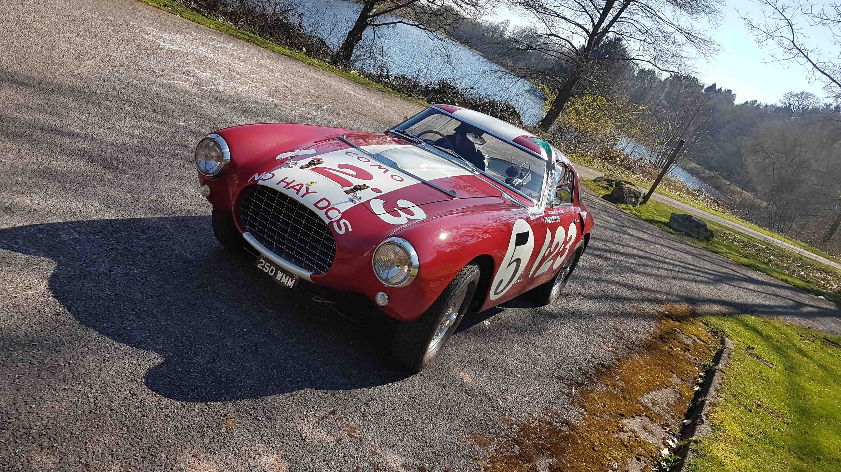
Sennheiser fuels the thrill of speed in Ferrari film
Sound designer Chris Jojo used Sennheiser wired and wireless mics to capture the remarkable sound in Michael Mann’s film

Wedemark, December 2024 – UK-based sound designer and sound recordist Chris Jojo has specialised in authentic car recordings for film, simulators and gaming. For the filming of Ferrari, which has been nominated for several sound design awards, he used, among other microphones, Sennheiser’s MD 421-II large-diaphragm microphone and AMBEO VR Mic, as well as the company’s evolution wireless plug-on transmitters and EK 6042 receivers to record the impressive sound of vintage Ferraris with impact and clarity. Jojo speaks about his way into vehicle recording and how he captured those engine sounds that make every fan’s heart beat faster.

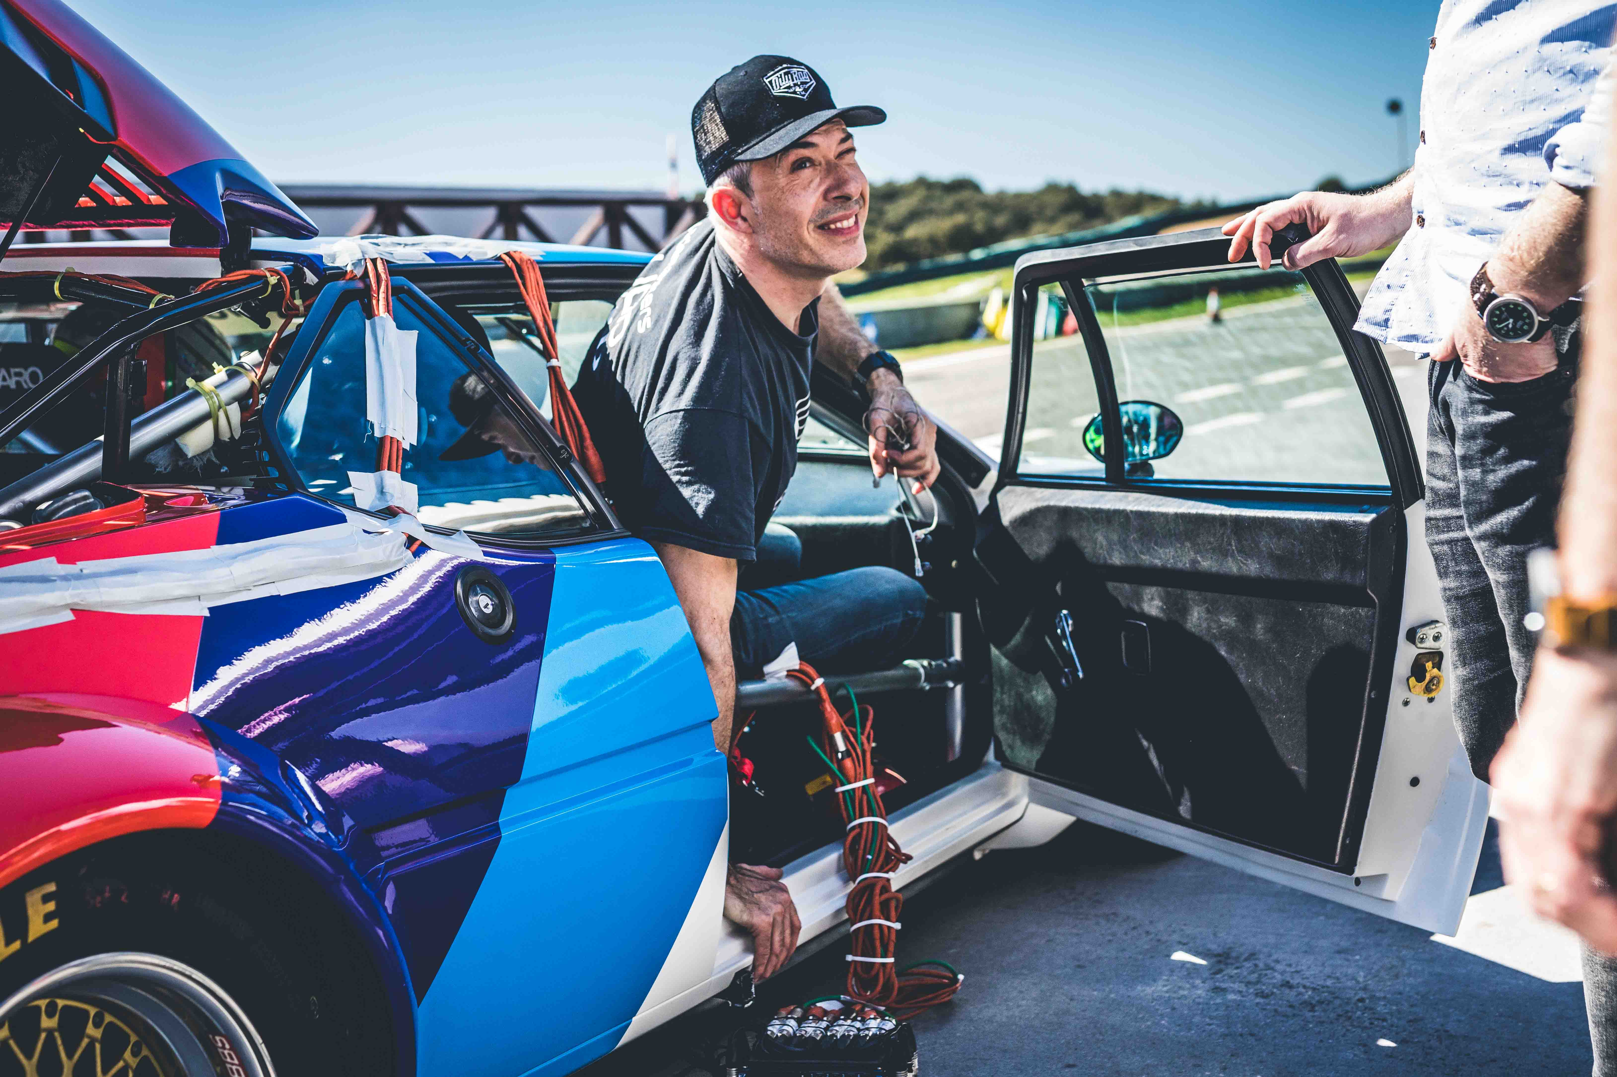 | Sound designer Chris Jojo is a specialist for authentic car recordings

“I have worked in the game software industry since 1992, when I joined Software Creations, a Manchester-based start-up, as a composer, musician, sound designer and artist for their games,” shares Jojo. Here, he had free reign to compose and underscore games, channelling his inspiration from the film industry. It was when he moved to Codemasters full time as a Senior Sound Designer in 2009 that he really began to focus on vehicle recordings.

"When I started with Codemasters, I had the opportunity to attend some recording sessions with Mark Knight, the Audio Lead on Codemasters DiRT3, and I really enjoyed the experience,” says Jojo. “I was fascinated by the process and the inherent challenges, especially in respect to miking very large, high-capacity engines that are incredibly loud in terms of SPL, like Formula, GT or certain Rally Car classes, mitigating the effect of wind on the exhaust mics, mic placement and getting the best off-axis response.”

Chris Jojo is fascinated by the challenges inherent to recording large, high-SPL engines like this Maserati 250F | 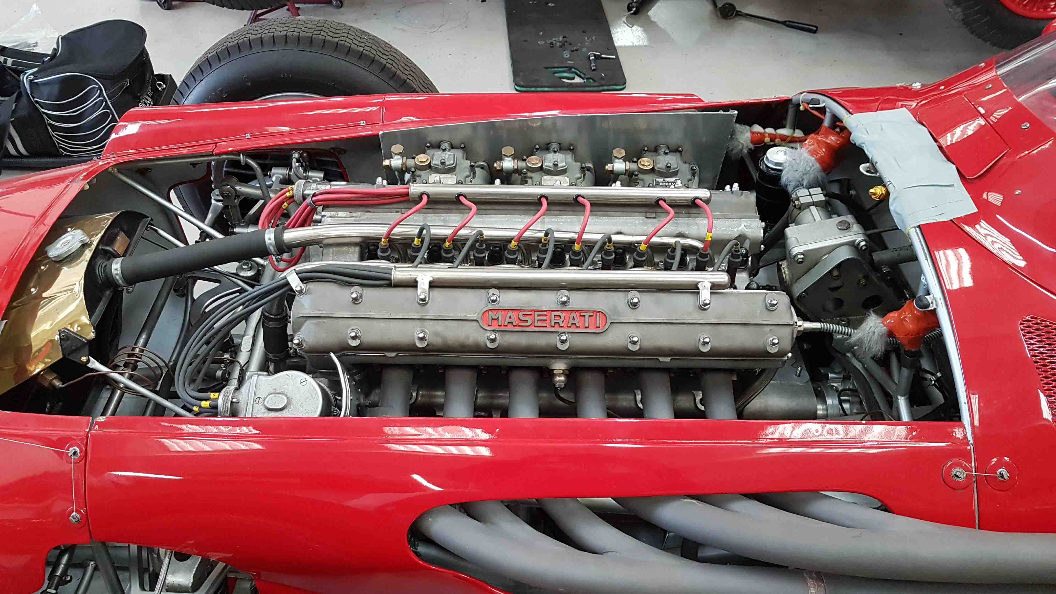

Soon, Jojo took ownership of car sound recording for the Codemasters Motorsports titles, ensuring the constituent components of the various Motorsports IPs were authentically captured to give the correct response for in-game action.

“With rally in particular, there’s a lot of interaction with the environment – primarily the car’s interaction with all terrain surfaces such as gravel, dirt, tarmac, mud, sand, etc. And when the player goes off race line, there are the impacts and collisions with elements within that environment,” he says. “There’s also dynamic weather: there might be snow, hail stones and all manner of rain conditions. It’s fantastic to have this huge scope of sound design components to integrate into the various facets of a rally game.”

Jojo also sources the cars licensed for recording, building upon relationships with motorsports teams, works, privateers, manufacturers’ heritage and private collections. Over the years, he has created an ever-increasing library of car recordings, including many iconic motorsports cars and rare historic marques. The relationships and trust cultivated with the owners is key – and not just for gaming: One contact directly led to his involvement with Michael Mann’s Ferrari film.

“I’d recorded a number of cars sourced through Nick Mason’s company Ten Tenths, an incredible collection that Nick has acquired over the years and has competed with, often making appearances at Goodwood’s annual Festival of Speed.

“Nick co-curated the ‘Motion. Autos, Art, Architecture’ exhibition with Sir Norman Foster at the Guggenheim Bilbao; I was involved in the sound recording of the ten selected cars that chronicled the evolution of the automobile for a timeline audio-visual installation undertaken by Sennheiser. Nick’s legendary Ferrari 250 GTO and Bugatti T35 were amongst the cars I recorded.”

Nick Mason’s legendary Ferrari 250 GTO | 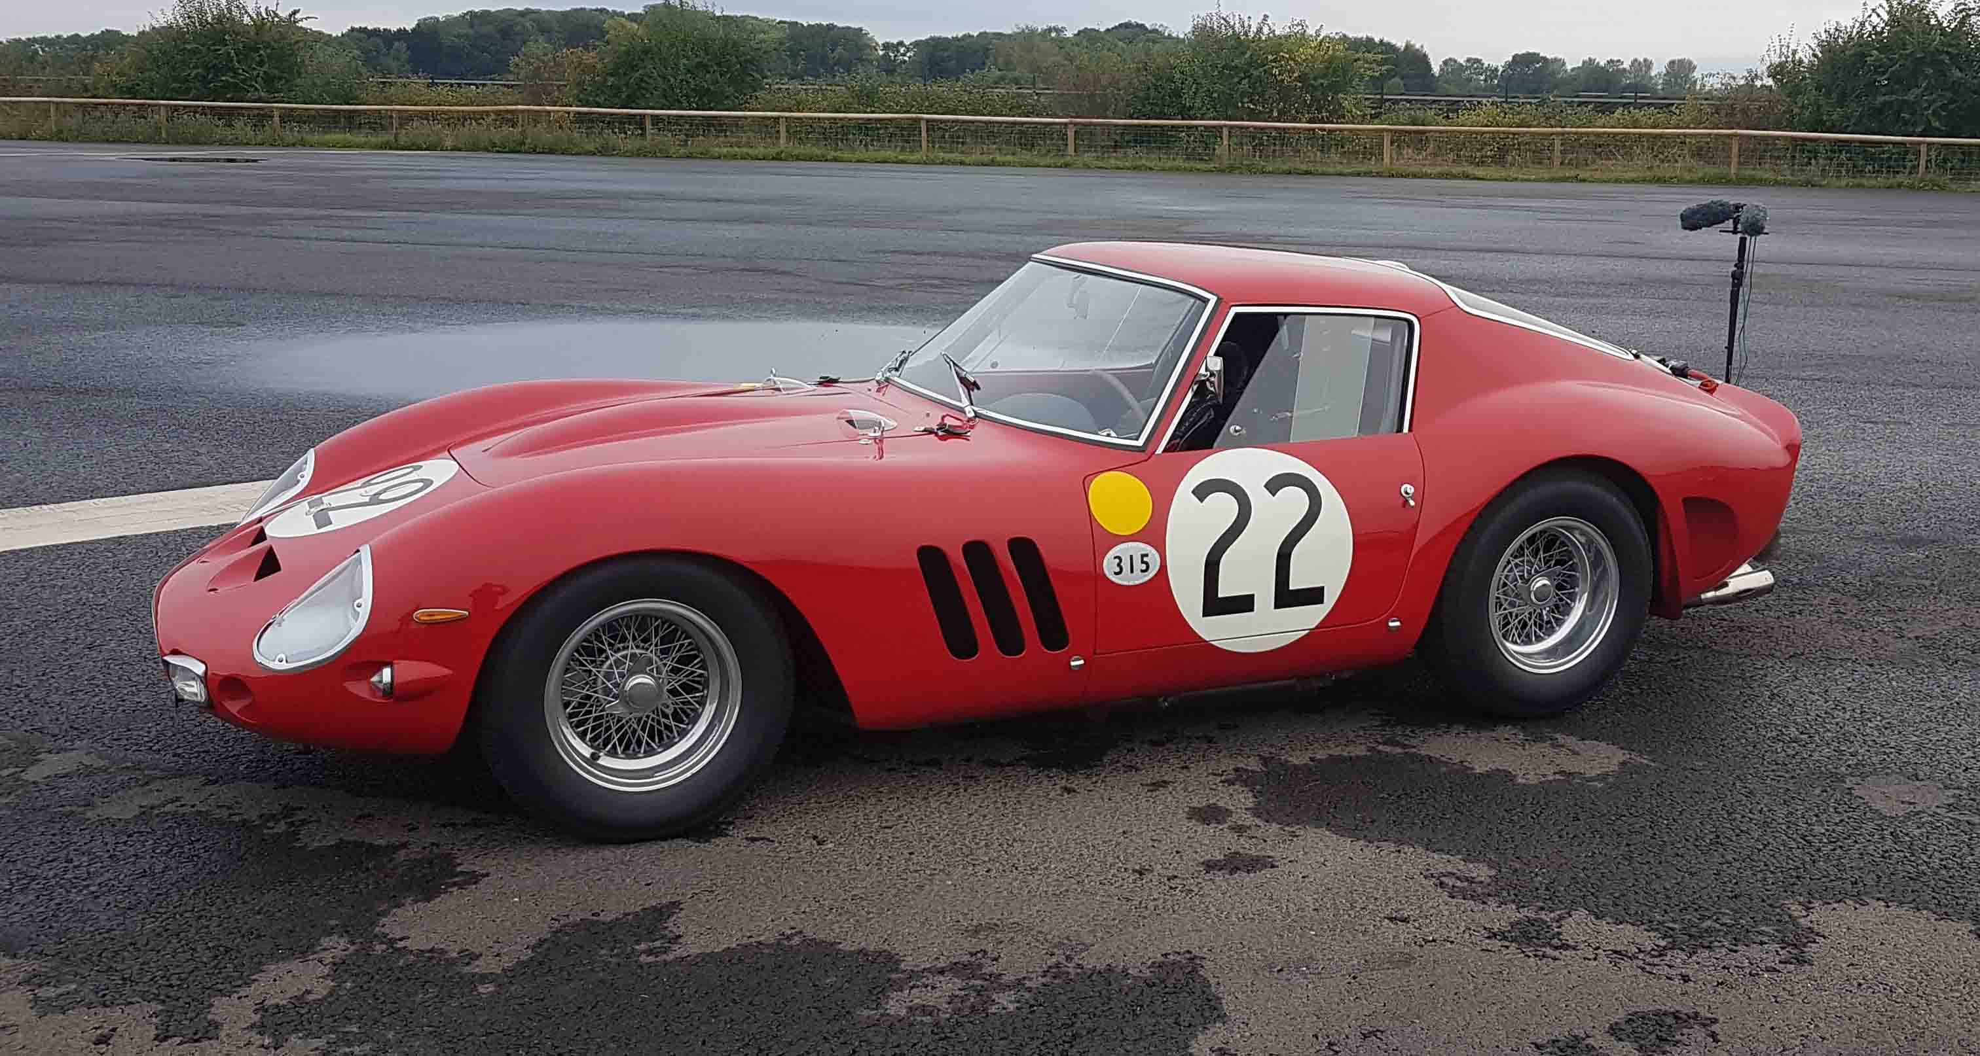

A few years down the line, Ten Tenths contacted Jojo to ask if he was interested in a Ferrari-based recording project for a film production that involved some of Nick’s cars. “I had an inkling then that it might be Michael Mann’s long-gestating Ferrari biopic, needless to say I jumped at the opportunity,” exclaims Jojo.

The biopic follows a pivotal period of Enzo Ferrari’s career, as he tried to turn his company and life around in the run-up to the 1957 Mille Miglia, a thousand-mile open road endurance race. Centre stage are the cars, and the film has been nominated for several awards, including a BAFTA nomination for best sound design.

Jojo’s role was car sound recordist. Ensuring the sounds were captured perfectly was a delicate balancing act between capturing the right sound and using mount positions that would ensure the mics would endure the day-long, high-speed on-track sessions.

“All of the onboard mics, looms and cabling I use are fire-treated with bespoke shrouds and enclosures; with motorsports cars, especially with high-capacity engine, high SPL cars, the amount of heat they can tolerate is pretty high. For engines, I generally favour larger diaphragm capsule mics with powered modular cables over lavaliers, but it all depends on the amount of space and suitable anchor points to mount them in an engine bay. Lav cabling and extender cables can be fragile and degrade over extended use. If you accidentally close a door on one or they get snagged, they’re finished. For engines I use 6-mm XLR cables terminating into the 3-mm cable loom of low-profile XLR connectors, so I have that peace of mind,” Jojo explains.

Even when recording individual sounds, the final, full sound picture is what is important. How the mics combine is key and Jojo takes a multi-mic approach, using a range of brands. One of the mics that he reaches for most often is the Sennheiser MD 421-II, a robust and versatile microphone. Its large diaphragm is capable of recording high-pressure sounds, and the full-bodied cardioid pattern makes it an excellent choice for most situations.

Jojo has to strike a fine balance between getting the right sound and making sure the mics endure the day-long, high-speed, on-track sessions. The exhaust on this Ferrari is miked with a combination of MD 421-II and omni mics, made wireless with the help of Sennheiser plug-on transmitters | 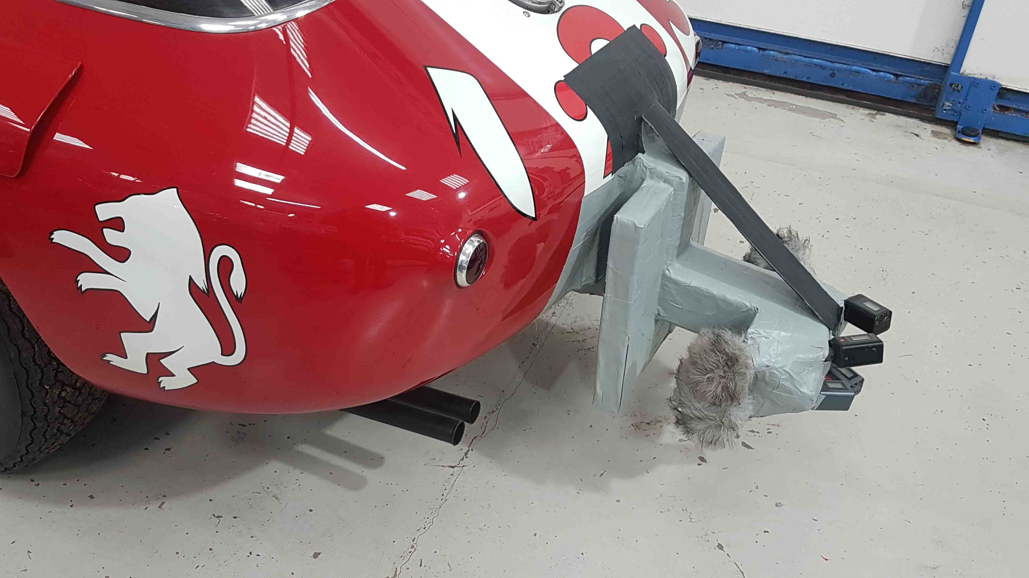

“With moving coil dynamics, you’re going to get a lag in transient response, but for what they lose in that, they make up for mid-range,” Jojo continues. “Mid-range is everything with cars, especially when the detail is on an exhaust, where the resonance is on induction with an air box or an intake manifold. If those are the areas that you want to accentuate, you need to use something larger than a miniature microphone and the MD 421 works well here. For exhausts, it blends beautifully paired with a high-SPL, large-diaphragm omni mic, with a more attenuated transient response.”

Due to the heat and confined space in the cars, Jojo uses slimline, fire-proof mounting methods, covering all his equipment in ingenious fire jackets that he makes himself. But it is not just the risk of fire that could jeopardise a take, interference can also come from electro-magnetic sources.

“Microphones have to be durable and hardwearing, and I have to know they can tolerate my kind of use,” he says. “Sometimes you get interference from cars if they are not steel shell, for example the Porsche 917, which has a fibreglass shell. Here, I add a metal mesh shroud that acts a little like a Faraday cage. I use Rycote baseball windjammers for the larger diaphragm microphones.”

In the in-cabin/driving position, Jojo often chooses the Sennheiser AMBEO VR Mic for its ability to accurately capture the feel of the cabin. In the Ambisonics B-format, the audio stays in sync, offering a perfect representation of the driving experience.

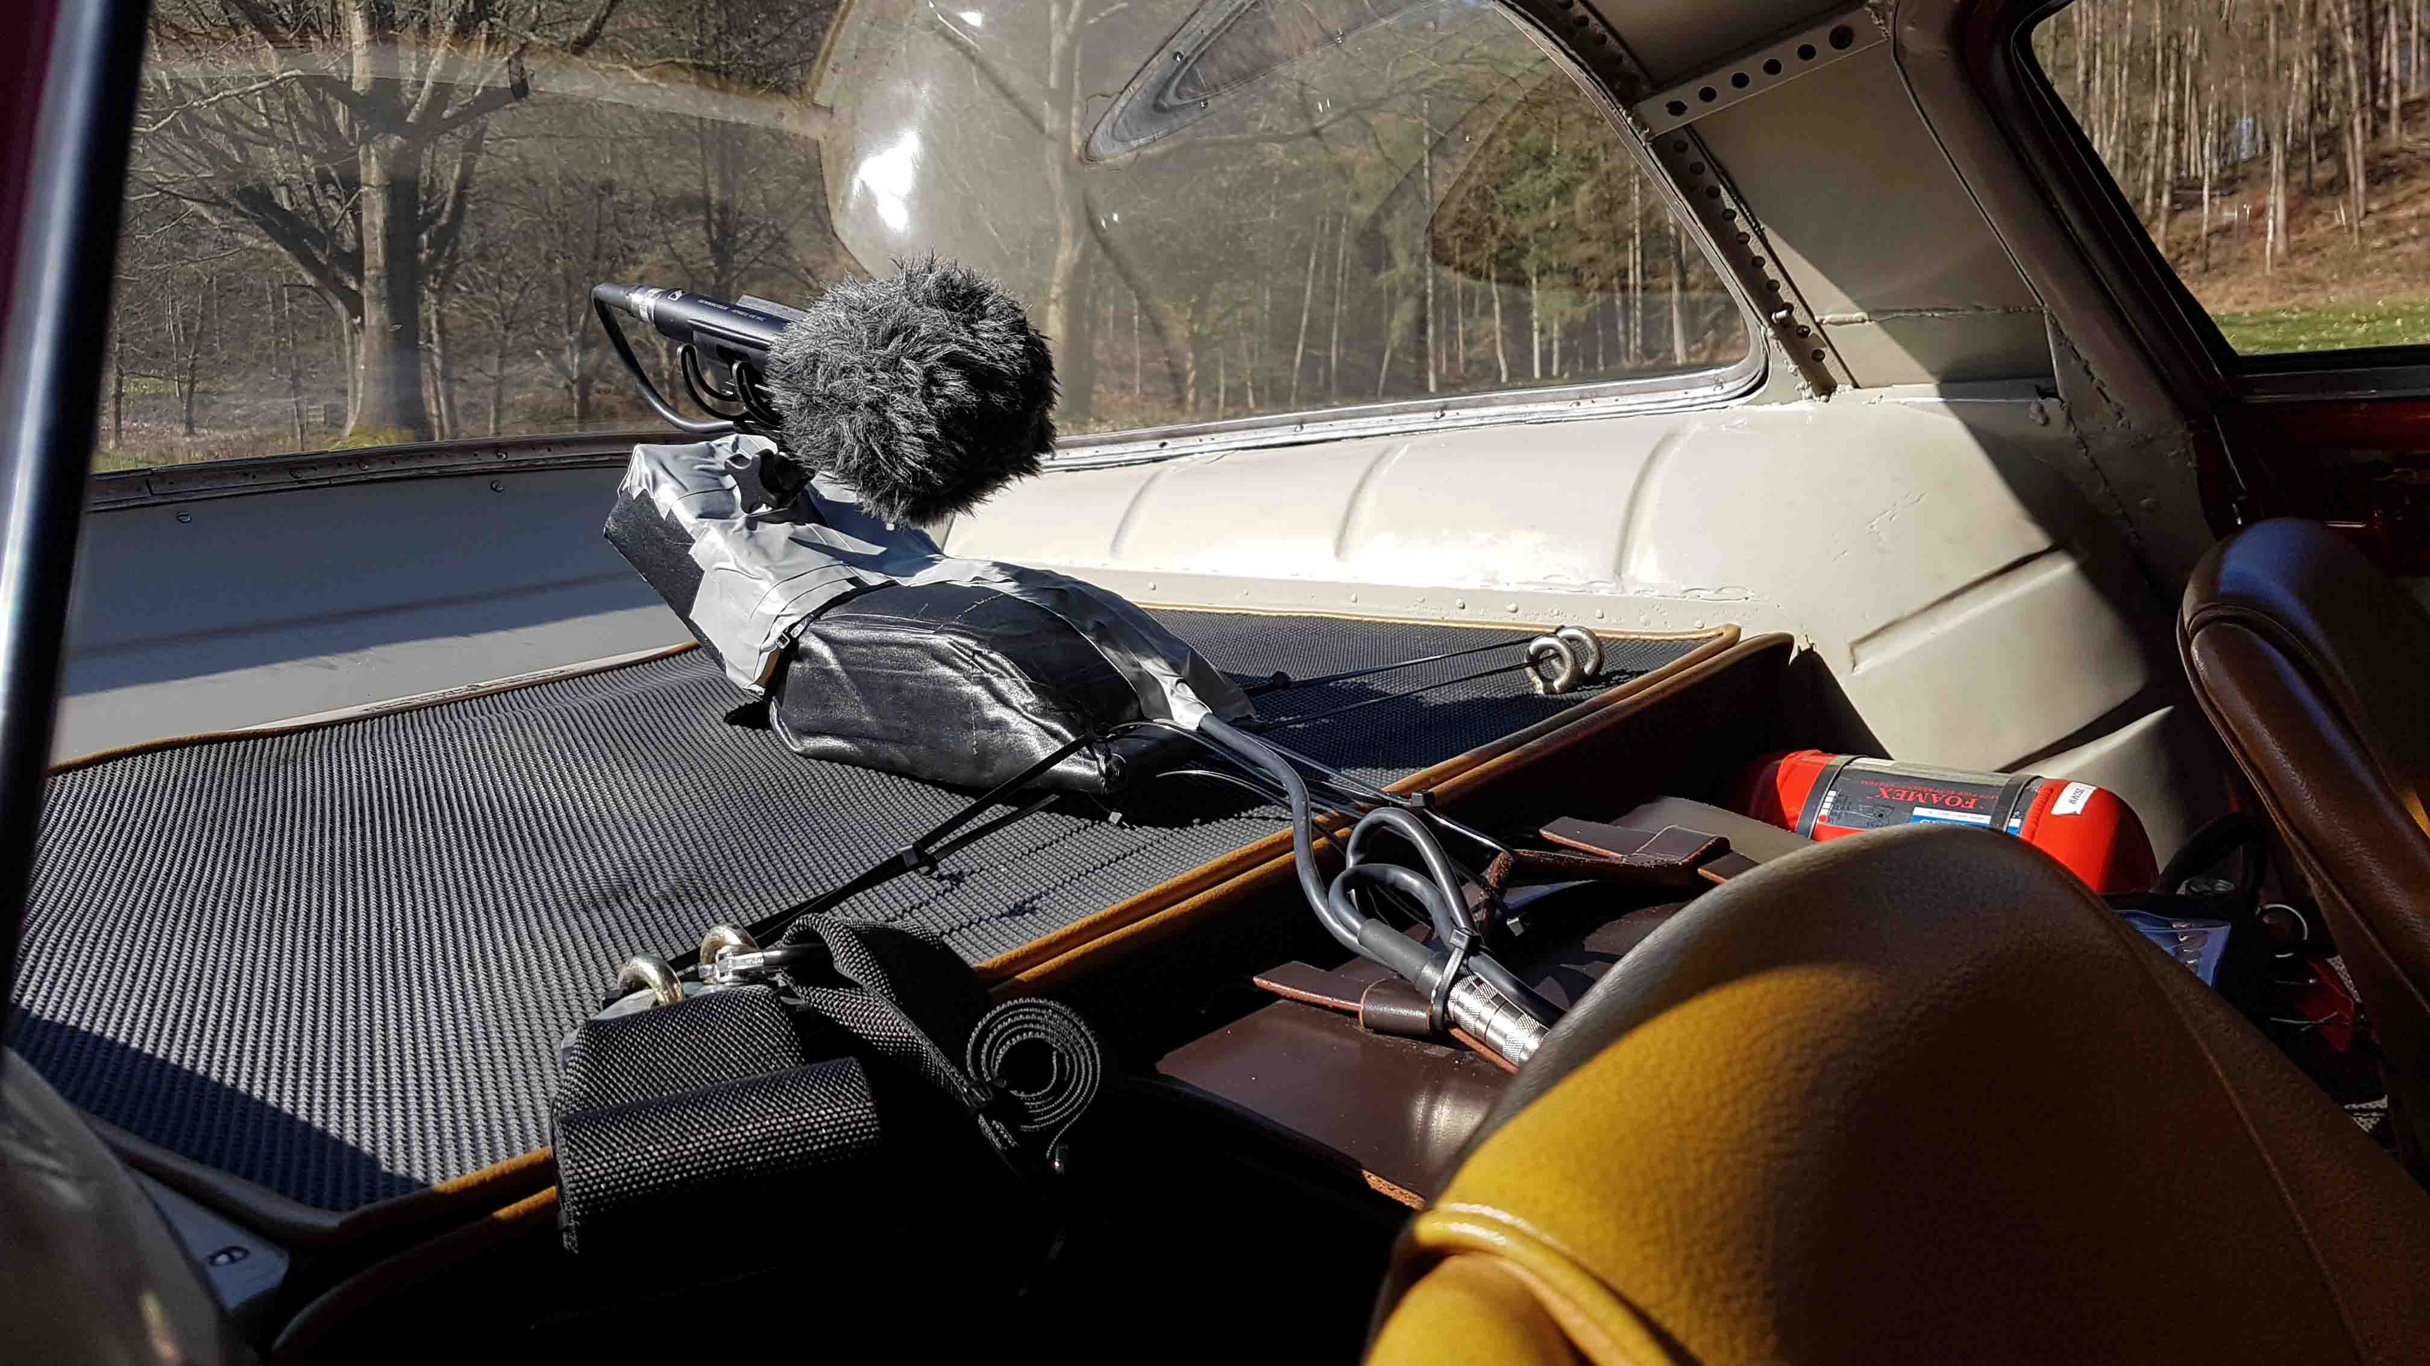 | Jojo often uses the AMBEO VR Mic to capture the feel of the cabin

Jojo is also a huge fan of the Sennheiser EK 6042 receiver and evolution wireless 500 series plug-on transmitters, owning four. “I’ve used them nonstop since I got them, they’re my default for all exhaust recording applications. They’ve never let me down, there’s never any interference, I haven’t had any sync problems, and the recorded quality is just flawless,” Jojo enthuses. “It’s lossless to my ears. On Ferrari, they were absolutely pivotal for recording the exhaust channels across all of the cars.

“For the recording of the Maserati 250F I had a pair of mics with SKP plug-on transmitters which were mounted just to the rear of the monocoque on the rear shell, literally pointing at the exhaust. They were heavily protected and shielded from buffeting airflow with windbreakers, but they were brilliant. They’re also great in wet weather and adverse weather conditions and I’ve never had any issue with heat either.”

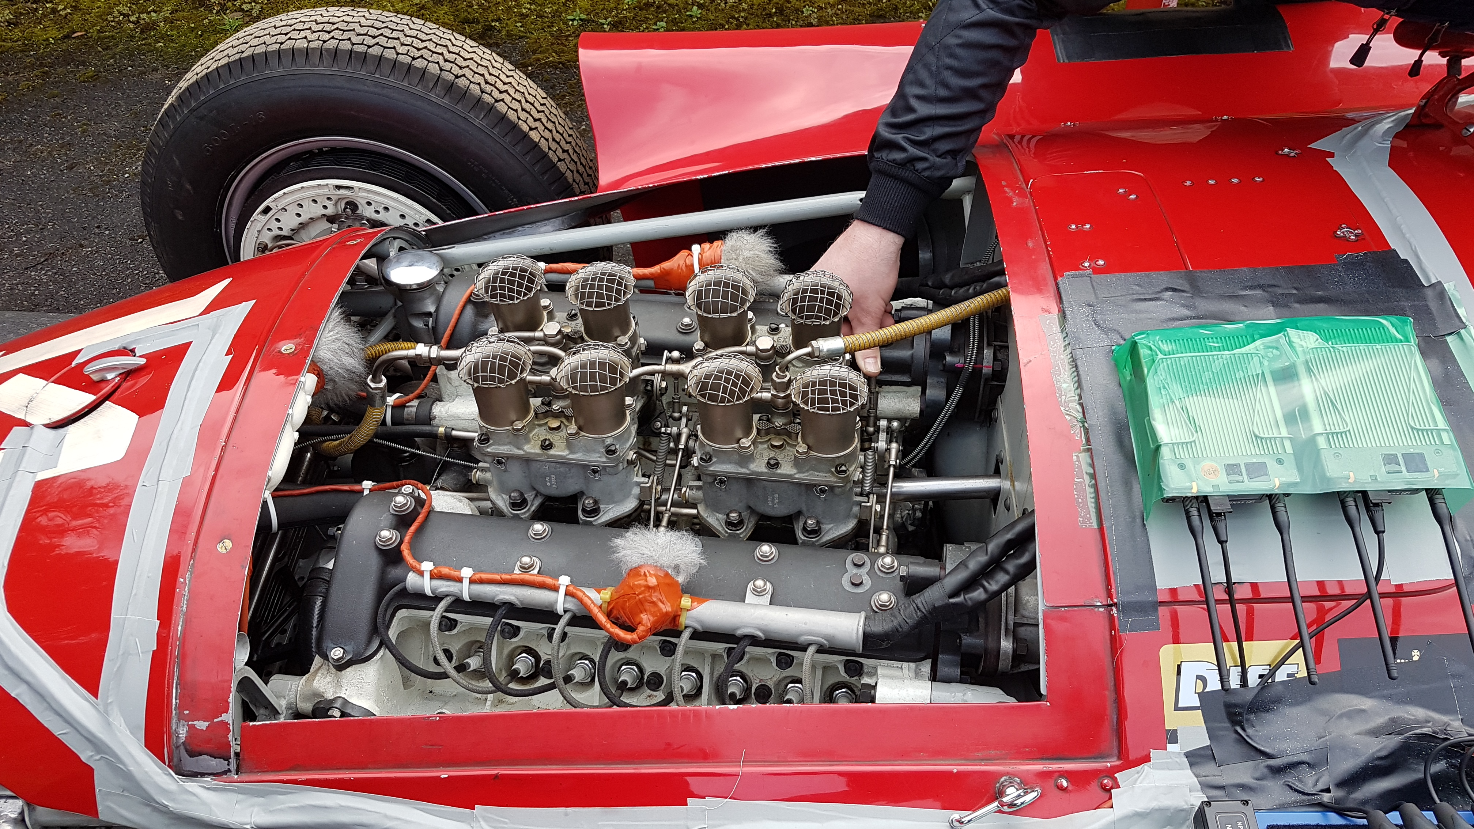 | To the right, two Sennheiser EK 6042 receivers mounted to the Lancia-Ferrari D50A, receiving audio from large-diaphragm mics made wireless by SKP plug-on transmitters

“I've always loved recording and the process of putting stuff down, from the early days of tape to where we are now with 32-bit floating point digital recorders. It’s amazing to see how things have advanced technologically,” Jojo concludes. “I had to record the limiter on the Ferrari 801 – the Lancia-Ferrari D50A – and that was really something. You don’t get to do that often with such iconic cars of this age and value. Capturing that mid-range bite was the MD 421-II, which for transient response, is one of the best moving coils I’ve ever used.”

(Ends)

The images accompanying this media release can be downloaded here.

About the Sennheiser brand
We live and breathe audio. We are driven by the passion to create audio solutions that make a difference. Building the future of audio and bringing remarkable sound experiences to our customers – this is what the Sennheiser brand has represented for more than 75 years. While professional audio solutions such as microphones, meeting solutions, streaming technologies and monitoring systems are part of the business of Sennheiser electronic SE & Co. KG, the business with consumer devices such as headphones, soundbars and speech-enhanced hearables is operated by Sonova Holding AG under the license of Sennheiser.

www.sennheiser.com
www.sennheiser-hearing.com

Global Pro Audio Press Contact
Stephanie Schmidt
stephanie.schmidt@sennheiser.com
+49 (5130) 600 – 1275

